Prime-number checking in a distributed game-tree engine

Prime Number Checking

Problem definition: given number N, return “YES” if the number is prime, else return “NO”. Pseudo code for a simple solution to this problem would be as follows:

Let N be the number to be checked
For A = 2 to (N / 2) do
If (N divides by A with no reminder) Return “NO”
Return “YES”

In order to compute the result in a distributed environment, one would have to decompose this problem into smaller sub-problems, distribute the sub-problems among some agents, collect the results back from the agents, and finally make the conclusion based on collected results.

One obvious way to decompose this problem is to divide the loop into smaller, consecutive ranges. Assume N is 100. Decomposition could look like this:

For A = 2 to 20 do
If (N divides by A with no reminder) Return “NO”
For A = 21 to 40 do
If (N divides by A with no reminder) Return “NO”
For A = 41 to 50 do
If (N divides by A with no reminder) Return “NO”
Return “YES”

Implementation of sub-problem solutions could be then further separated from the implementation of the main problem:

If (IsPrimeInRange(100, 2, 20) = “NO”) Return “NO”
If (IsPrimeInRange(100, 21, 40) = “NO”) Return “NO”
If (IsPrimeInRange(100, 41, 50) = “NO”) Return “NO”
Return “YES”

Function IsPrimeInRange (NUMBER, LOW, HIGH)
For A = LOW to HIGH do
If (NUMBER divides by A with no reminder) Return “NO”
Return “YES”

Parallel distribution of the three sub-problems would then be simply achieved by making IsPrimeInRange function a non-blocking remote procedure call and inserting some synchronization code.

Mini-Max Engine

Let’s assume that we have available software (an engine) that can perform distributed mini-max search on a genetic game-tree. The engine would require connection with a set of game-specific agents. Agents can be ordered by the engine to perform computations on parts of the game tree.

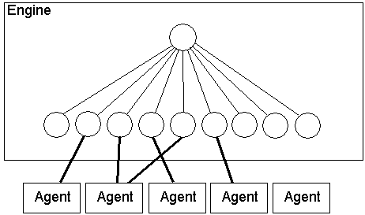

Let’s assume that each agent provides following interface:

Function Split (GAME_STATE, PLAYER) – given the game state and the player that is about to make a move, return list of possible games states that might follow.

Function Evaluate (GAME_STATE, PLAYER) – return quality of the given game state for given player.

By manipulating the agents, the engine has power to create game trees, evaluate quality of nodes and finally decide on the best move. Assuming that engine is just a middle-man between the agents and some game-specific client, it does not have to be aware of the syntax of semantics of game states or players:

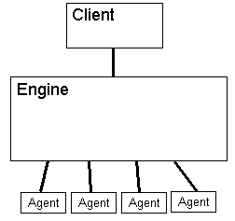

Mapping the Prime Number Checking

It is possible to write an agent that will fit the Mini-Max engine framework and allow the engine to solve the Prime Number Checking problem. Knowing that engine will pick the node of highest quality on a maximizing level and the node of lowest quality on a minimizing level, the agent can trick the engine to pick the right answer to the prime-check problem. Here is pseudo code for the agent’s interface implementation:

Function Split (GAME_STATE, PLAYER)
// GAME_STATE is either:
// just a number to be checked (e.g. “17”), or
// a number flowed by low-bound and hi-bound for checking (e.g. “17,2,9”), or
// “NA”
// PLAYER is either:
// MAXIMIZING, or
// MINIMIZING

If (PLAYER = MAXIMIZING)
YES_QUALITY = 1
NO_QUALITY = 2
PROBABLY_QUALITY = 0
Else
YES_QUALITY = -1
NO_QUALITY = -2
PROBABLY _QUALITY = 0

// Tree branching be adjusted depending on the number of Agents anticipated
Let B = 5 // branching
If (GAME_STATE = “NA”) return empty set of game states
If (GAME_STATE is a single number N)
NUMBER = N
LOW = 2
HIGH = N / 2
If (GAME_STATE is in form “N,L,H”)
NUMBER = N
LOW = L
HIGH = H
Divide range (LOW, HIGH) into B consecutive, adjacent partitions P1, P2 ... PB

// return all the possible game states:
// we preset the initial qualities in case the mini-max engine requires it
Let RESULT be an empty set of game states
Let YES_GAMESTATE be a game state
YES_GAMESTATE.GAMESTATE = “NA”
YES_GAMESTATE.MOVE = “YES”
YES_GAMESTATE.QUALITY = YES_QUALITY
Add YES_GAMESTATE to RESULT
For each partition P in (P1, P2 ... PB)
Let NEW_GAMESTATE be a game state
NEW_GAMESTATE.GAMESTATE = “NUMBER,L,H”, where L and H are specified in P
NEW_GAMESTATE.MOVE = “NO”
NEW_GAMESTATE.QUALITY = MAYBE_QUALITY
Add NEW_GAMESTATE to RESULT
Return RESULT

Function Evaluate (GAME_STATE, PLAYER)

// GAME_STATE is either:
// just a number to be checked (e.g. “17”), or
// a number flowed by low-bound and hi-bound for checking (e.g. “17,2,9”), or
// “NA”
// PLAYER is either:
// MAXIMIZING, or
// MINIMIZING

If (PLAYER = MAXIMIZING)
YES_QUALITY = 0
NO_QUALITY = 2
Else
YES_QUALITY = 0
NO_QUALITY = -2

If (GAME_STATE = “NA”) return YES_QUALITY
If (GAME_STATE is a single number N)
NUMBER = N
LOW = 2
HIGH = N / 2
If (GAME_STATE is in form “N,L,H”)
NUMBER = N
LOW = L
HIGH = H

For A = LOW to HIGH do
If (NUMBER divides by A with no reminder) return NO_QUALITY
Return YES_QUALITY

Sample Scenarios

Let’s assume that the engine is to check number 101 (a prime). Let’s assume that the engine is always trying to maximize the numeric quality of its moves. Right after making the first node split, the game-tree would look something like this:

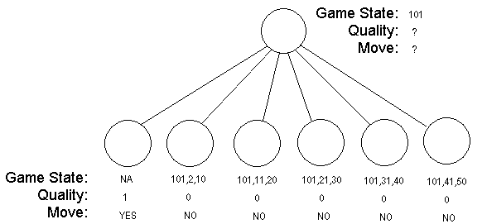

After running evaluations on all leaf nodes, none of the leaf-node qualities would change. Since the engine would be trying to maximize its move quality, it would pick the first node and then return “YES” as its move. This would indicate to an outside client that the number is prime.

Lets now look at the evaluation process of number 100 (not a prime).
The tree split would produce similar tree:

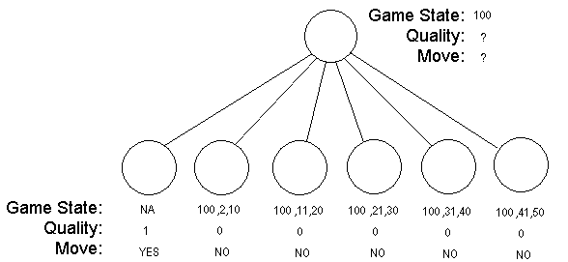

However, after evaluating all the leaf nodes, the tree would look like this:

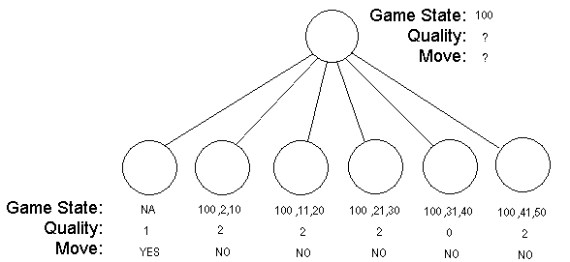

Numerical quality of 2 at a maximizing level indicates that there is at least one number in the range that divides number 100 with the reminder of 0. One of the states with quality of 2 would be picked and move “NO” would be returned.

Conclusions

In the above explanation, the engine is assumed to operate using the Mini-Max algorithm and performing only one-level split. However, the methodology here presented would work as well in a distributed Alpha-Beta algorithm with uneven, multi-level splits. Additional features that could be added to the agent interface could include performance reporting which could help the engine with load balancing, scheduling, etc.

Prime number checking is just one of many divide-and-conquer search problems in computer science. Other such problems could be mapped onto the distributed game-tree search.

